[Application Form]
After completing the online application, print it out and submit it along with the required documents.
Application for Graduate School Admission
수험번호
Application No.
인적사항  Personal  Information | 성명  Name | 한글성명  (In Korean) |  |  |  |  |  |  | Photo  (3×4cm)
인적사항  Personal  Information | 성명  Name | 영문성명  (In English) |  |  |  |  |  |  | Photo  (3×4cm)
인적사항  Personal  Information | 성명  Name | ＊여권 또는 다른 공식문서와 동일하게 기재  (Write your name exactly as it appears on passport or other official document.) |  |  |  |  |  |  | Photo  (3×4cm)
인적사항  Personal  Information | 국적  Nationality |  |  | 성별  Gender | □ Male □ Female |  |  |  | Photo  (3×4cm)
인적사항  Personal  Information | 여권번호  Passport Number |  |  | 생년월일  Date of Birth |  |  |  |  | Photo  (3×4cm)
인적사항  Personal  Information | 주소  Address | 우편번호  Zip code |  |  |  |  |  |  | Photo  (3×4cm)
인적사항  Personal  Information | 주소  Address | 상세주소  Number and Street |  |  |  |  |  |  | Photo  (3×4cm)
인적사항  Personal  Information | 전화번호(국가번호/지역번호/번호)  Telephone  (Country Code/Area Code/Number) |  |  |  |  | 휴대전화번호  Cellphone
지원정보  Application Information | 지원 과정  Planned Degree |  |  | □ 석사 (Master’s Program)
지원정보  Application Information | 지원  모집단위  Desired Major | 학과  Department
지원정보  Application Information | 지원  모집단위  Desired Major | 전공  Major
어학능력  Language Proficiency | Korean Proficiency Level |  |  | □ TOPIK (level )
어학능력  Language Proficiency | English Proficiency Test Score |  |  | □ TOEFL( ) □ TOEIC( ) □ TEPS ( ) □ IELTS ( )
학력정보  Academic Information | 학사정보  (Bachelor’s Degree) | 대학 University
학력정보  Academic Information | 학사정보  (Bachelor’s Degree) | 학과 Department |  |  |  | 전공  Major
학력정보  Academic Information | 학사정보  (Bachelor’s Degree) | 수료여부  Degree Status |  | □ Degree Granted  □ Degree Expected
학력정보  Academic Information | 학사정보  (Bachelor’s Degree) | 위치  Location |  | 국가(Country) |  |  | 도시(City)
학력정보  Academic Information | 학사정보  (Bachelor’s Degree) | 재학기간  Date of attend |  | from yyyy / mm / dd to yyyy / mm / dd
학력정보  Academic Information | 석사정보  (Master’s Degree) | 대학 University
학력정보  Academic Information | 석사정보  (Master’s Degree) | 학과 Department |  |  |  | 전공  Major
학력정보  Academic Information | 석사정보  (Master’s Degree) | 수료여부  Degree Status |  | □ Degree Granted  □ Degree Expected
학력정보  Academic Information | 석사정보  (Master’s Degree) | 위치  Location |  | 국가(Country) |  |  | 도시(City)
학력정보  Academic Information | 석사정보  (Master’s Degree) | 재학기간  Date of attend |  | from yyyy / mm / dd to yyyy / mm / dd
수험번호
Application No.

거주 정보  Residence Information | □ Out of Korea
거주 정보  Residence Information | □ In Korea | 외국인등록번호  Alien Registration No. |  | - | 비자 만료기간  Visa Validity
거주 정보  Residence Information | □ In Korea | 한국비자종류  Visa Status |  |  | 주소  Address
비상 연락처  Emergency Contact |  | 우편번호  Zip-code
주소
Address
전화번호
Telephone
이메일 주소
E-mail
Wechat ID
Skype ID
상기 입학원서 및 제출하는 서류의 모든 내용은 사실이며, 추후 본 서류에서 허위 또는 잘못 기재된 사실이 있을 경우에는 귀교의 결정에 따를 것을 서약합니다.

I certify that the information I have provided on this application, including personal statements and any other information, is complete, accurate, and is my own work. I understand inaccurate information may affect my admission including cancellation of admission after enrollment.

2026. . .

Name of Applicant
수험번호
Application No.

[Form 1]
Study plan

□ Name :
※ Please write down your purpose in studying at Chungnam National University and your plans for study. Be as specific as you can regarding your academic interests and the curriculum you expect to follow in achieving your goals.

Signature of Applicant : |  | Date(YYYY/MM/DD) :

[Form 2]
Personal Statement
1. Personal Information
▪ Name (English):
※ Write your English name exactly as it appears on passport or other official document
▪ Degree Program Applied for: □ Master’s degree
▪ Department Applied for:
▪ Marital status: □ Single □ Married
YYYY/MM/DD | Place | Position | Activities
~
~
▪ Work Experience and Achievement
2. Family Relations
Relationship | Name | Date of Birth | Nationality | Telephone
Father
Mother

Name | Relation | Telephone | Cell Phone
3. Emergency Contact

Language | Excellent | Good | Fair | Poor
Korean
English
4. Proficiency in Foreign Languages

I certify that all information in this application is true.

Signature of Applicant : |  | Date(YYYY/MM/DD) :

【 | Appendix 2 | 】 | 충남대학교 캠퍼스 맵 / Campus Map
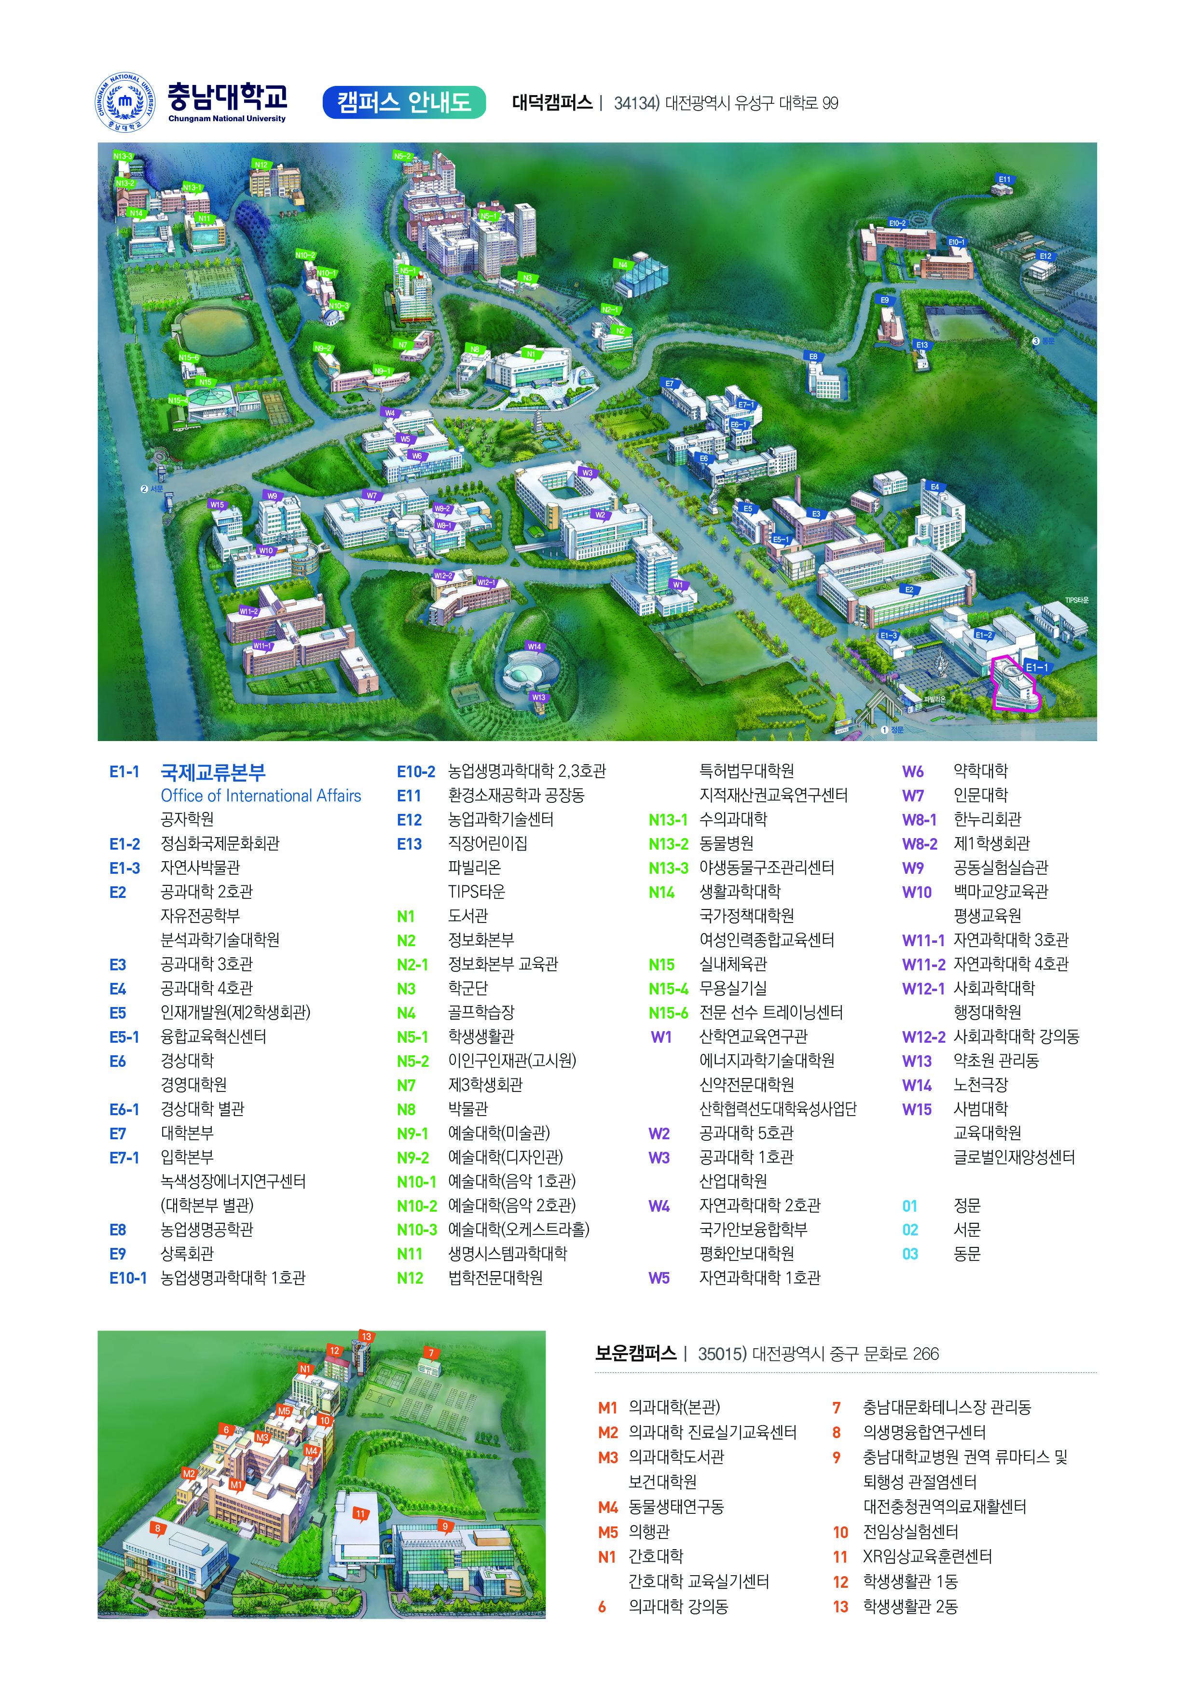

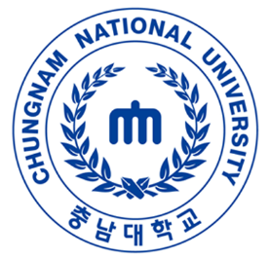 | Office of International Affairs
 | Website  CNU Potal  CNU Admissions  CNU Graduate School | http://www.cnu.ac.kr  http://ipsi.cnu.ac.kr/html/gadm/  http://grad.cnu.ac.kr/ | 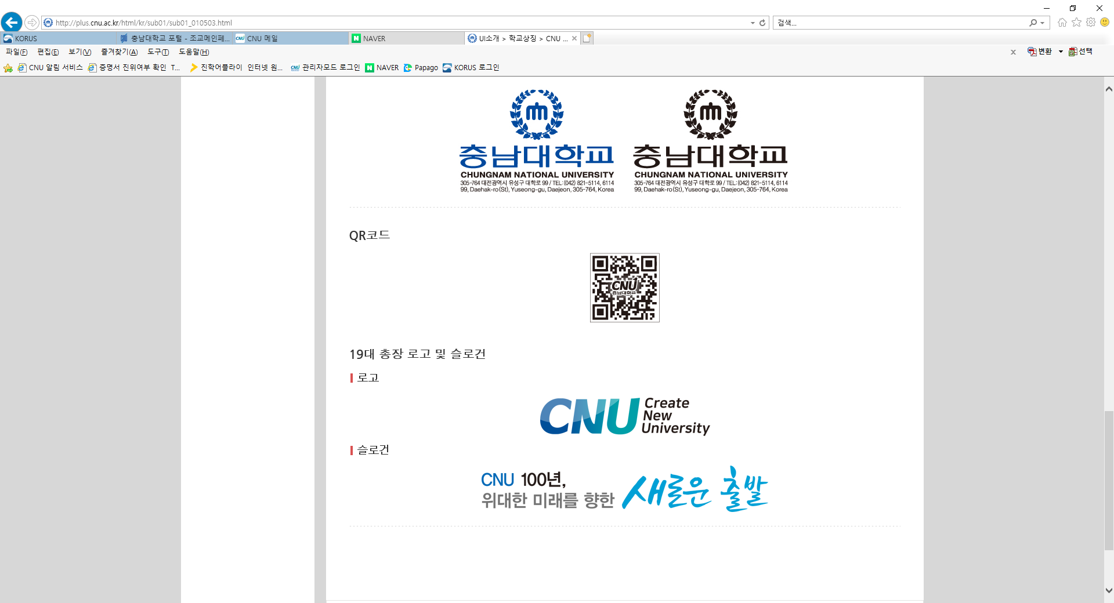
Telephone +82-42-821-8826
Email nextfellowship@cnu.ac.kr
Mailing Address
(Zip code) 34134 / 205, International Affairs Office(E1-1) in Chungnam National University,
99 Daehak-ro, Yuseong-gu, Daejeon, Republic of Korea
Office Hours Weekdays 9am ~ 6pm (Lunch break 12pm ~ 1pm)

